All about me and my family

My name is:

My birthday is:

Do you call your child by another name?

What name would you like us to use?

My parents/ carers:
Name:

Relationship:

What does your child call you?

What would you like us to call you?

Name:

Relationship:

What does your child call you?

What would you like us to call you?

Who will usually drop your child to preschool?

Who will usually collect your child from preschool?

Do you/ your child know any children that already attend Kingsley Road Preschool? (promoting this bond can help during settling)

My birth story…
Is there anything you’d like to share with us about your pregnancy, child’s birth or health?
Such as: birth complications, any issues throughout pregnancy, prematurity, illness, hospital admissions etc

My home life...
What type of home do you live in? (House, flat, bungalow, garden, no garden)

Who lives with you and your child? (Please include names and their relationship to your child and family)

Do you have any pets? (If so, please include names)

What is your religion?

Are there any special events/ cultural celebrations that your family takes part in? (i.e Diwali, Holi, Easter)

Do you attend any places of worship? (i.e mosque, temple, church)

My experiences…
Do you manage to get out and about with your child? If so, please tell us where... (i.e playgroup, park, swimming, shops)

How would you describe your child when you are out and about? (please circle below)



Confident
Unsettled
Weary
Shy
Happy
Anxious
Unsociable
Calm
Sociable

Eating…
How is your child with eating? (Do they eat independently? Do you have to feed them? Can they use cutlery or drink from a cup independently?)

Does your child have any allergies or dietary requirements? (If yes, please provide us with details)

How has your child’s eating journey been? (Does your child enjoy eating? Can eating be stressful at times? Is your child a picky eater?)

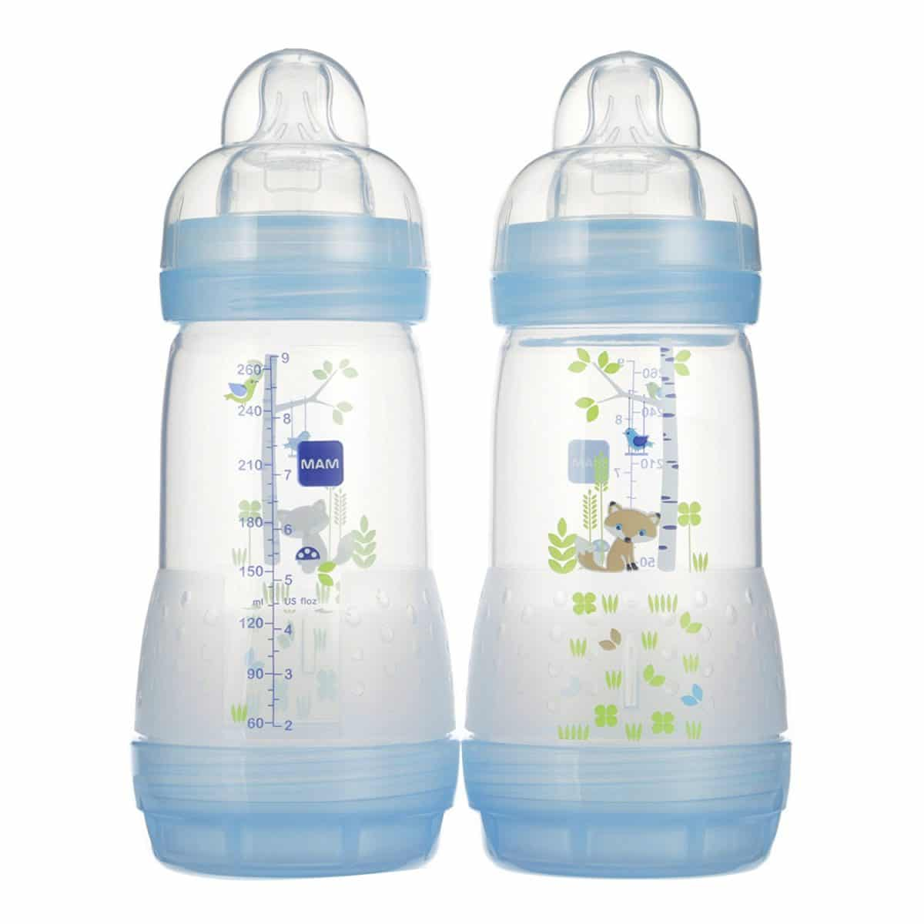
Hands/ fingers
Knife
Spoon
Fork
Sippy cup/ beaker
Baby bottle
Normal cup
What does your child eat with? (tick)
What does your child drink with? (tick)




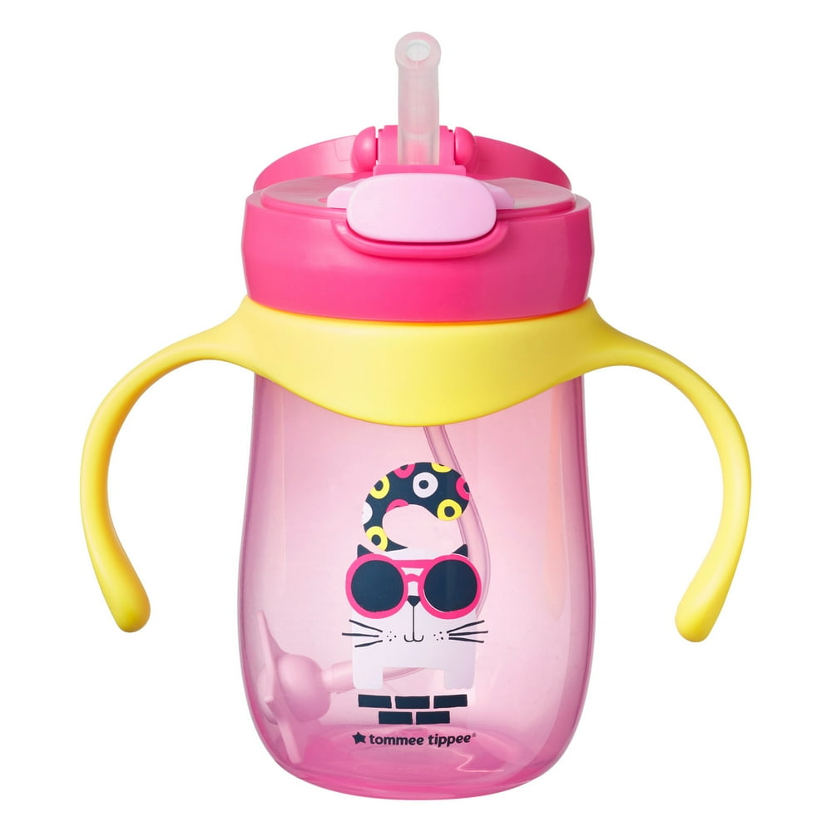


My sleeping routine

Can you tell me about your child’s sleeping? (Can it be difficult for your child to go to bed or to fall asleep? Does their bedtime change daily? Does your child wake up through the night?

Does your child take naps during the day? (If so, what time/s?)

Where does your child sleep during the night? (Please tick)
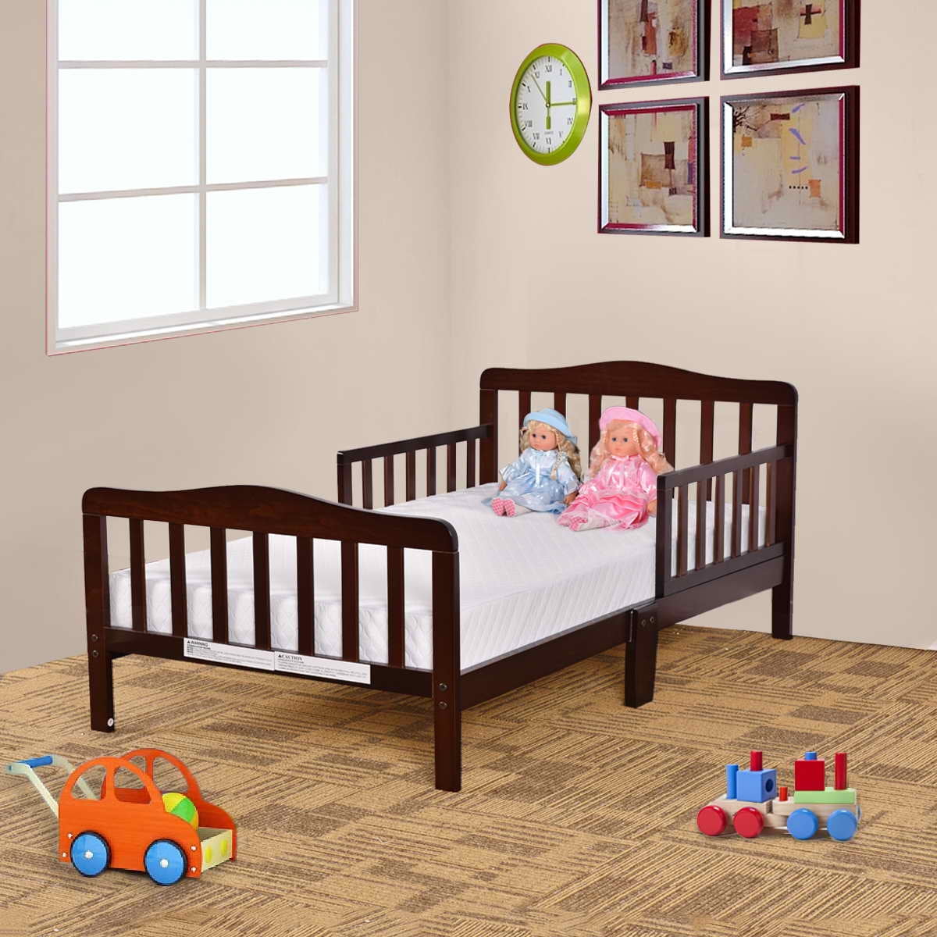
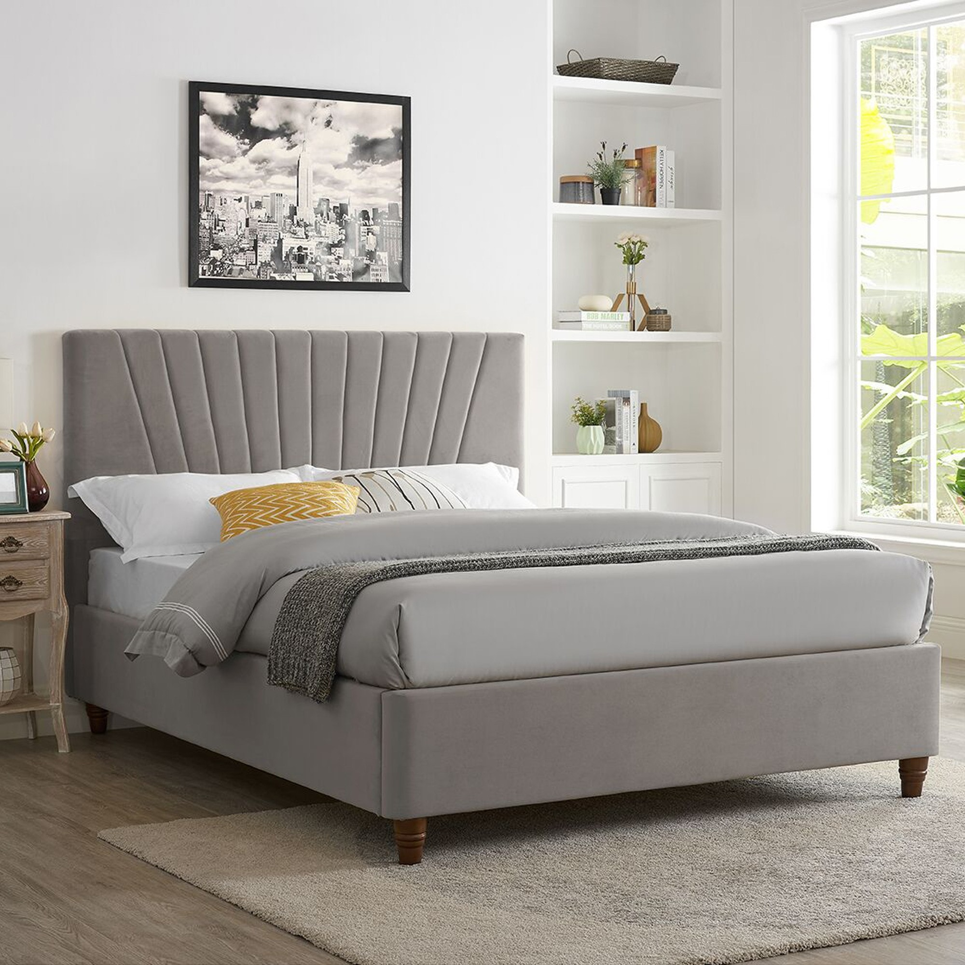
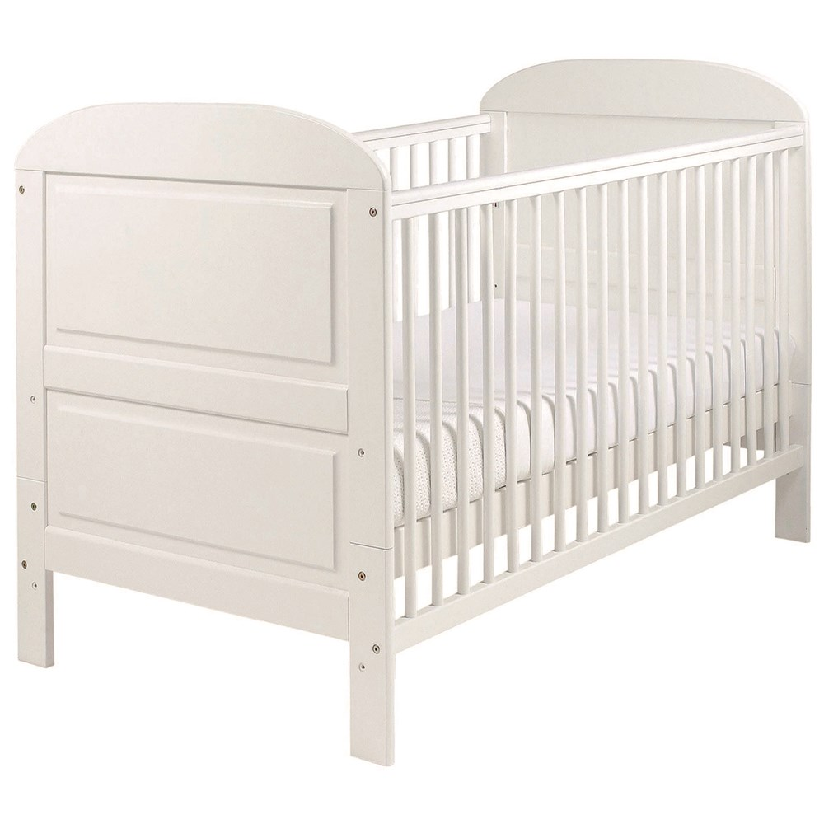
If somewhere else, please write below:
Own bed
Parent’s/ siblings bed
Cot

Does your child sleep with any comforter? (Please tick)
If something else, please add below:
Teddy/ Soft toy
Dummy/ Pacifier
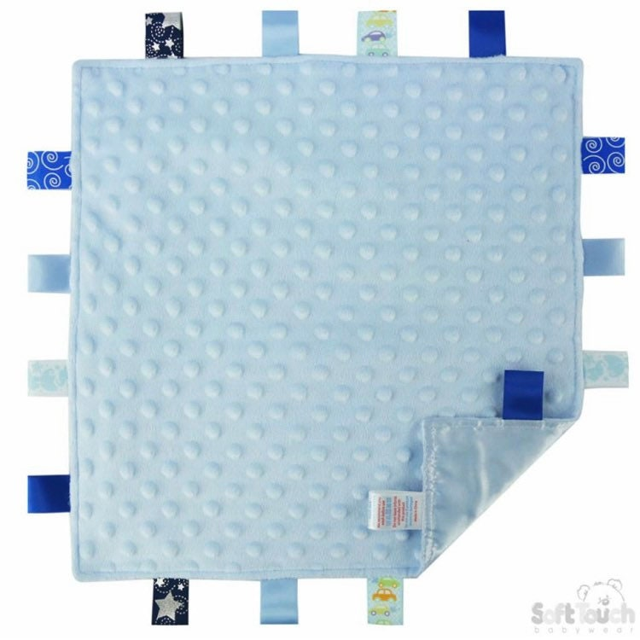
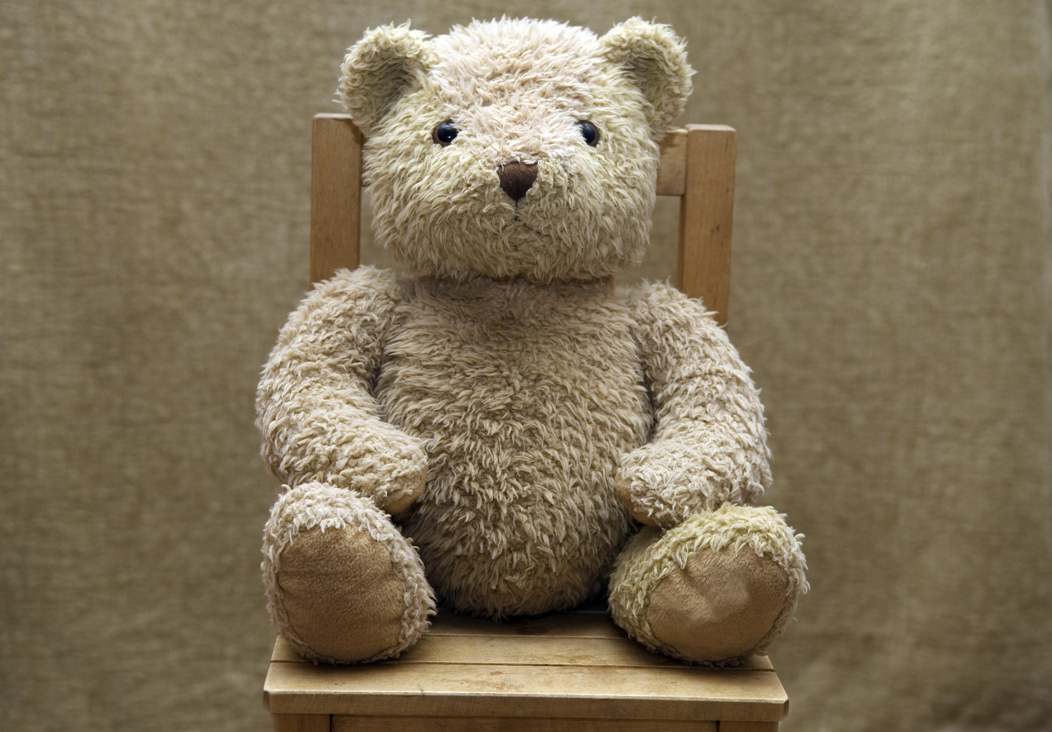

Comfort blanket

My language and communication
What language/s does your child understand and speak at home? (Or exposed to if they are not yet talking)

Is your child exposed to English at home? (i.e Television, YouTube, others speaking English)

Does your child understand and/ or speak English?

How does your child communicate their needs to you…

If they are hungry/ thirsty?

If they are tired?

If they are not feeling well?

If they want something?

If they need the toilet/ nappy change?
Key words in my language
Milk

Food/ Eat/ Hungry
Drink



Home
Dad
Mum

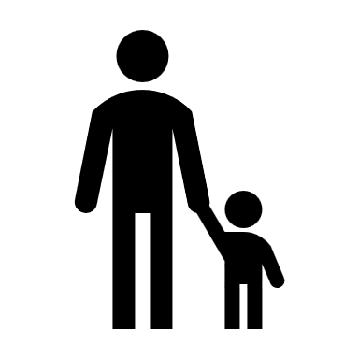
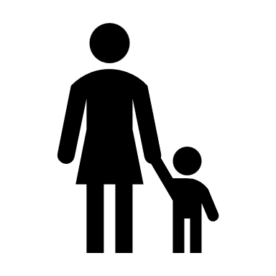

Toilet
Nappy



Any other words that we should be familiar with?

How do you feel about this transition?
How do you feel about your child starting preschool?

Do you have any worries about this transition? If so, please tell us

What are you looking forward to during this transition?

How do you think your child feels about starting preschool and have you had a chance to discuss it with them?

Has your child ever seperated from you before? If so, how did it go?

Has your child spent time with other children before? If so, how did it go?

My temperment and personality
How would you describe your child and their personality? (Please circle all that are relevant)

Shy
Active

Sensitive

Confident
Cautious

Prefers quiet/ being alone

Easily distracted
Active

Sociable
Add your own..
Add your own..

When I use the toilet/ my nappy
Please tell us more about how your child uses the toilet/ potty or their nappy.
When I use the toilet, I like to… (please tick)
Use the potty

Use the toilet

Sit down

Stand up

I can do this independently

I need help with this

When I have my nappy changed, I prefer to be… (please tick)

Laying down

Standing

Is there anything else that you would like to tell us about this?

Technology I am familiar with
Please circle the devices that your child can independently use
Mobile phone
Tablet/ iPad
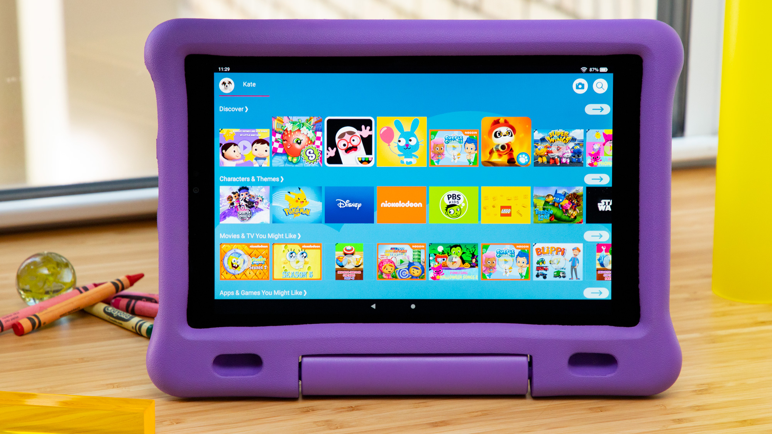
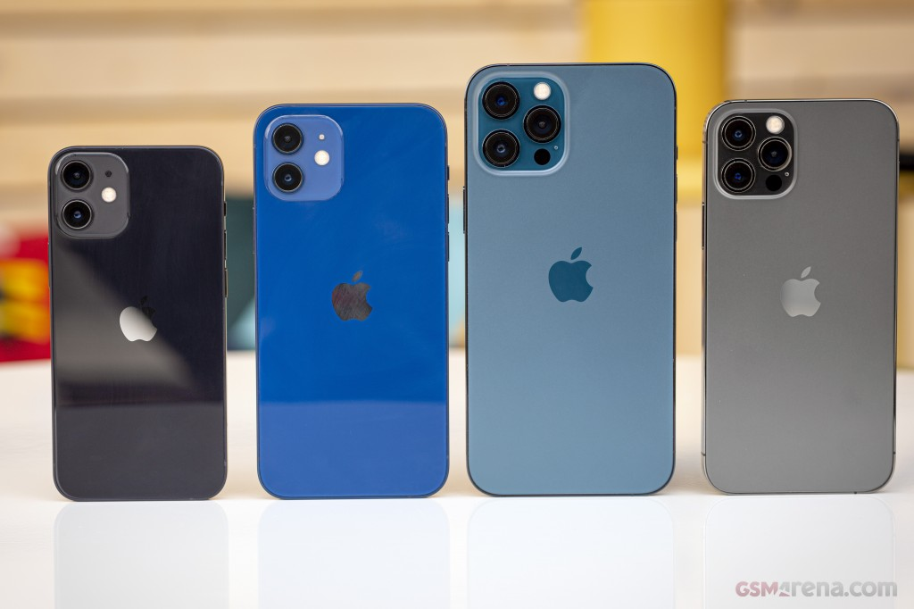

Laptop/ Computer
T.V/ Remote control
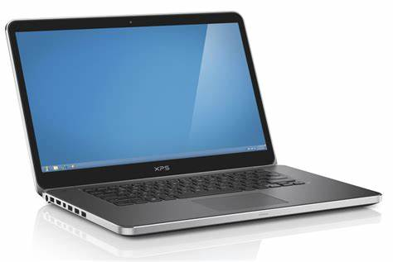
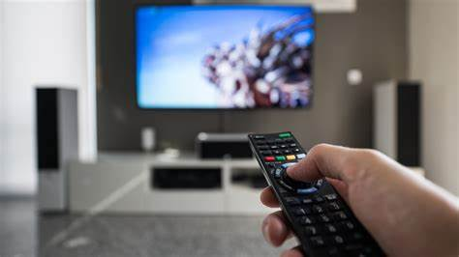

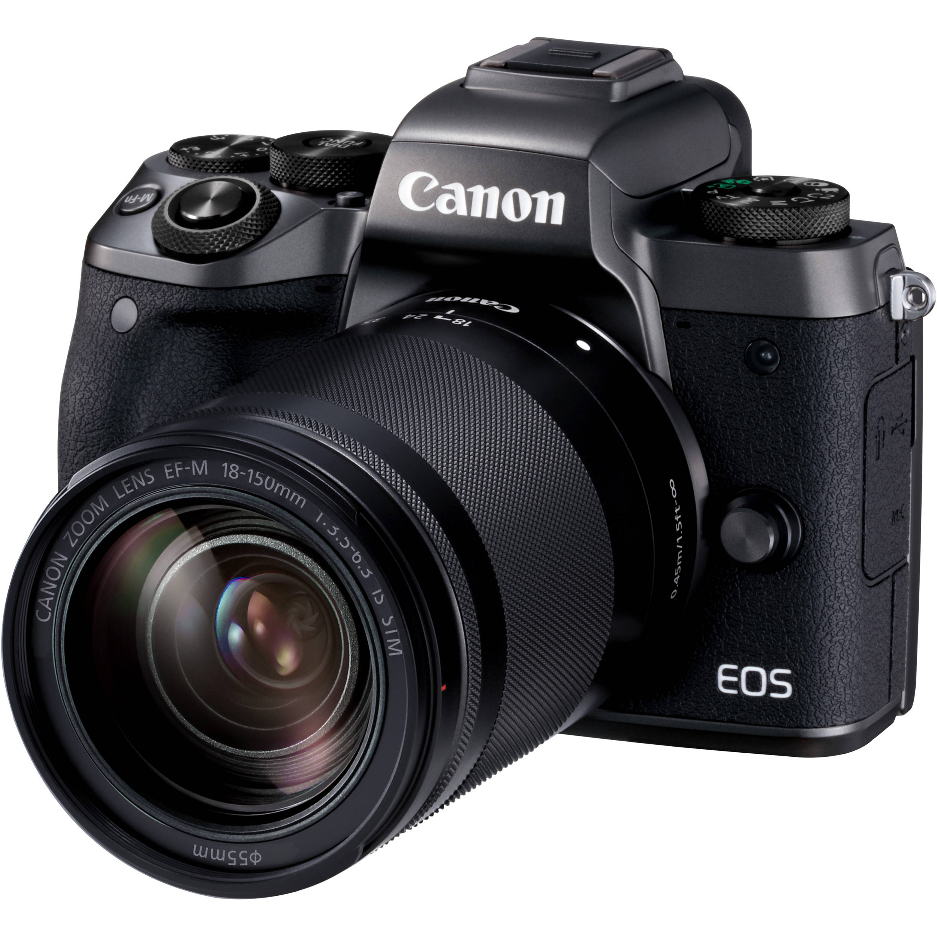
Camera
Washing machine
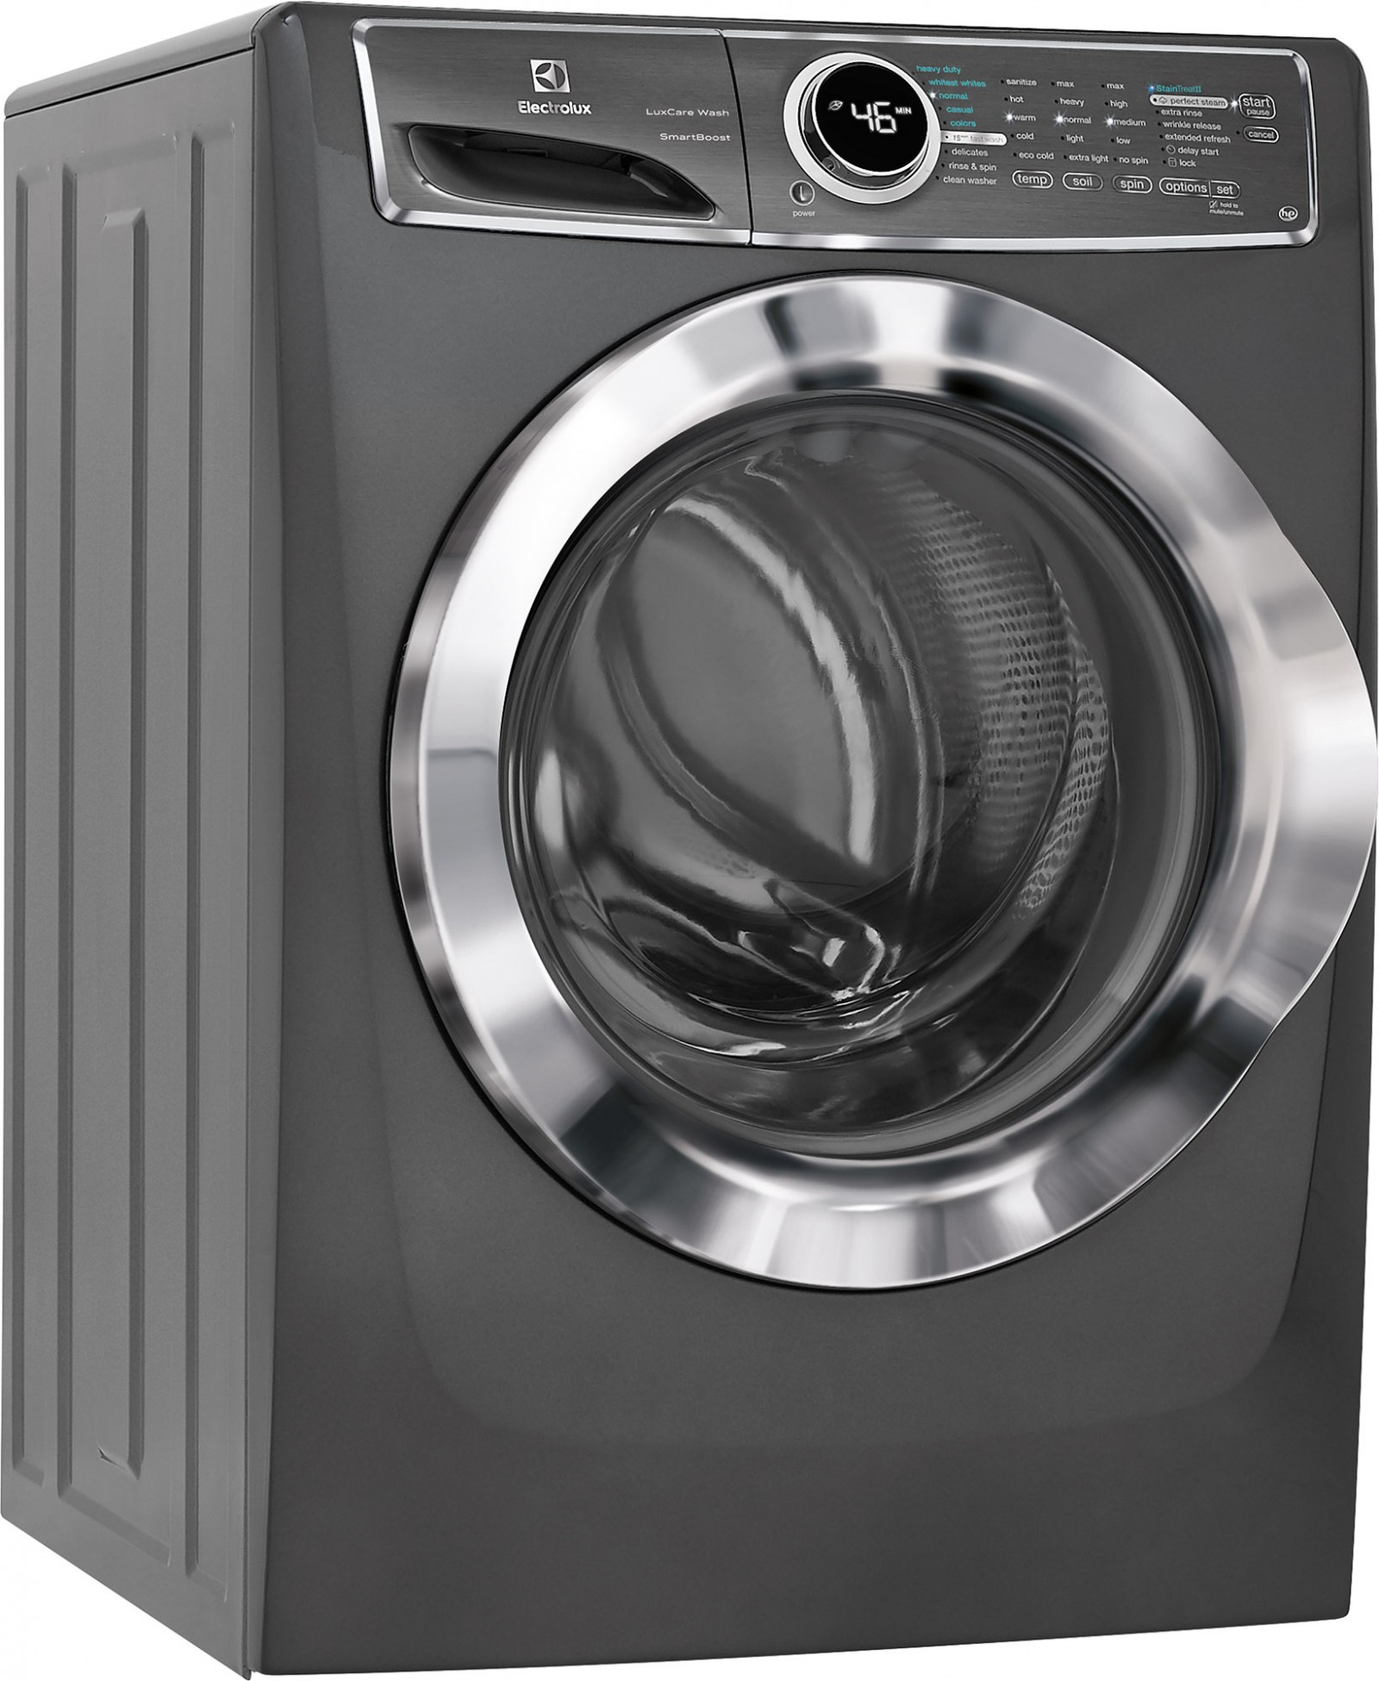
Game consoles
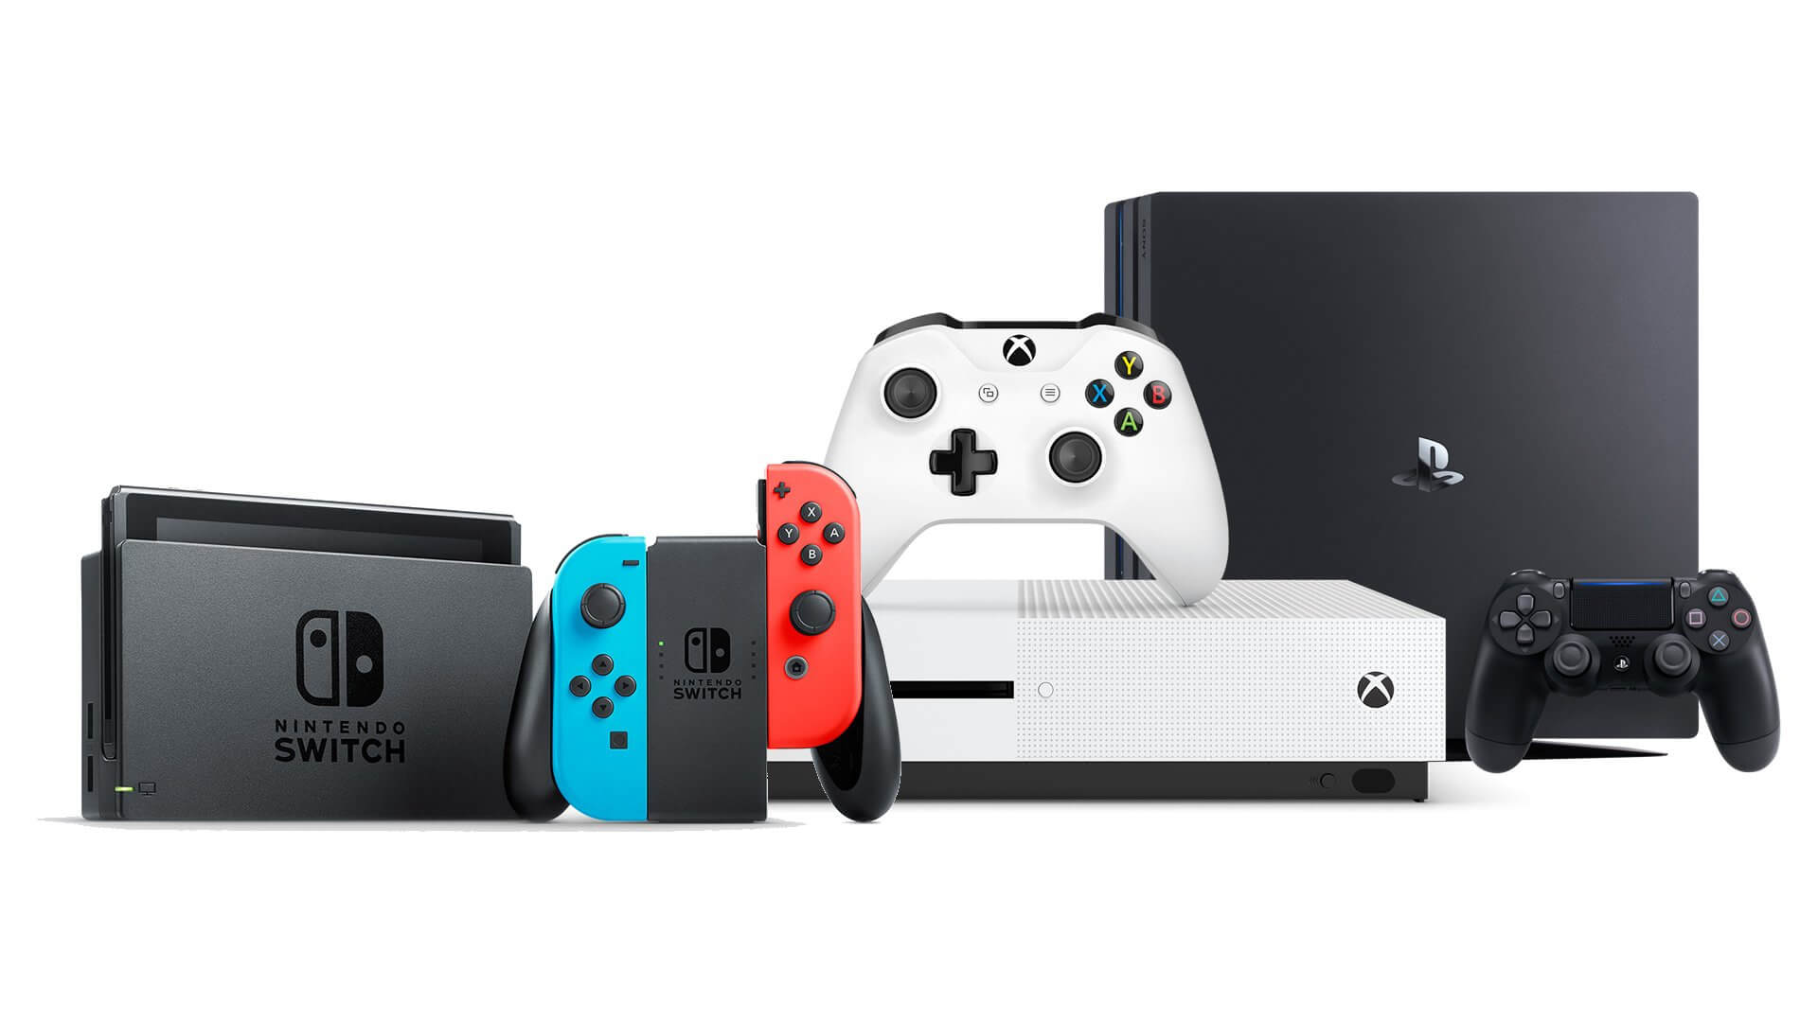

My development
Is there anything you would like us to know or are concerned about, regarding your child’s development?

I can …….. (to be completed with your child’s key person)
Personal, Social and Emotional Development:  - I join in with others when playing  - I am starting to pretend when playing  - I sometimes have tantrums when I am frustrated  - I am able to show what I like and don’t like | Comments:
Communication and Language:  - I enjoy rhymes & stories  - I understand simple sentences (e.g. throw the ball)  - I can ask simple questions  - I can use simple sentences  (e.g. Mummy gone work) | Comments:
Physical Development:  - I can run and kick a ball  - I can balance blocks and build a tower  - I can hold a cup and drink without spilling  - I can feed myself | Comments:
Literacy:  - I am interested in books and rhymes  - I know and repeat words and phrases from my favourite story  - I can fill in missing words from favourite rhyme or story  - I can make marks with meaning | Comments:
Mathematics:  - I sometimes group my cars or teddies together  - I can say some counting words  - I can do simple inset puzzles and shapes  - I use language of size (big, small) | Comments:
Understanding the World:  - I can imitate everyday actions in present play (making a cup of tea)  - I enjoy playing with small world toys (farm, train, zoo)  - I can tidy up and know where things belong  - I can operate toys with buttons, flaps and simple mechanisms | Comments:
Expressive Arts and Design:  - I can move to music and join in with finger rhymes  - I can create sounds with musical instruments  - I can begin to make believe by pretending  - I can use marks to create a ‘picture’ | Comments:

